Doc Spot – Full Stack MERN Project Documentation

Introduction
Project Title: DocSpot – Online Doctor Appointment Booking System Team Member:M.Sanjeevi

Project Overview Purpose:
DocSpot is designed to digitize and simplify the entire doctor appointment booking process. The primary purpose of the system is to eliminate traditional manual booking methods by offering a secure, fast, and user-friendly online platform. It provides patients, doctors, and administrators with seamless access to essential features such as real-time appointment scheduling, profile management, and data tracking.

DocSpot aims to:
  - Allow patients to easily find doctors based on specialization, availability, and location.
  - Provide a structured platform for doctors to manage appointments and patient interactions.
  - Enable administrators to manage users, doctors, approvals, and overall platform activities.
  - Improve healthcare workflow efficiency by reducing delays and manual effort.
  - Ensure secure and authenticated interactions using a robust MERN-based infrastructure.

Features:
    - User authentication (JWT-based)
    - Patient dashboard and appointment booking
    - Doctor dashboard for managing schedules and appointments
    - Admin panel to manage doctors, users, and appointments
    - Real-time notifications
    - Secure API integration

Architecture Frontend (React.js):
  - React with Hooks and Context API
  - Axios for API calls
  - Bootstrap/Material UI for styling
  - Protected routes using React Router

Backend (Node.js + Express.js):
  - RESTful API
  - Authentication middleware
  - Role-based access control

Database (MongoDB + Mongoose):
  - Collections: Users, Doctors, Appointments
  - Schema validation using Mongoose models

Setup Instructions

Prerequisites:
  - Node.js (v16+)
  - MongoDB or MongoDB Atlas
  - Git

Installation Steps:
- Clone the repository.
- Install dependencies for frontend & backend: npm install
- Configure .env in backend:
  - MONGO_DB="mongodb_connection_string"
  - JWT_SECRET="your_secret"
- Start frontend & backend.

- Folder Structure

Client (React):
  - /src/components – UI Components
  - /src/pages – Screens
  - /src/context – Global state
  - /src/utils – Helper functions

Server (Node.js):
  - /routes – API routes
  - /controllers – Business logic
  - /models – Mongoose schemas
  - /middleware – Auth & security layers

- Running the Application Frontend: npm start Backend: nodemon index.js
- API Documentation

User APIs:
- POST /api/user/register – Register user

- POST /api/user/login – Login user
- GET /api/user/profile – Get user profile

Doctor APIs:
- POST /api/doctor/apply – Apply as doctor

- GET /api/doctor/appointments – Get doctor appointments
- POST /api/doctor/update-status – Update appointment status

Appointment APIs:
- POST /api/appointment/book – Book appointment

- GET /api/appointment/user-appointments – User appointments
- POST /api/appointment/check – Check availability

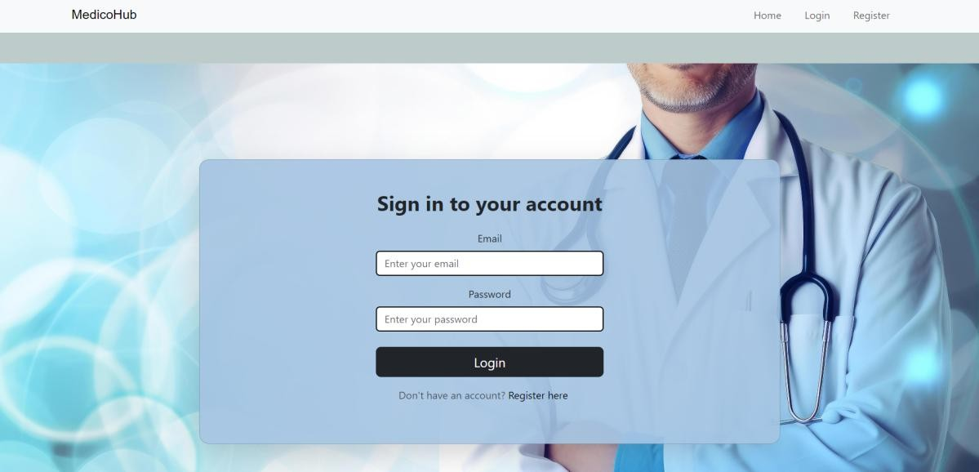
Admin APIs
- GET /api/admin/get-all-doctors – Fetch all doctors
- POST /api/admin/update-doctor-status – Approve/Reject doctor

- GET /api/admin/get-all-users – Fetch all users
- GET /api/admin/all-appointments – Fetch all appointments

Authentication:
  - JWT-based authentication
  - Tokens stored in local Storage
  - Role validation: user, doctor, admin

- User Interface:

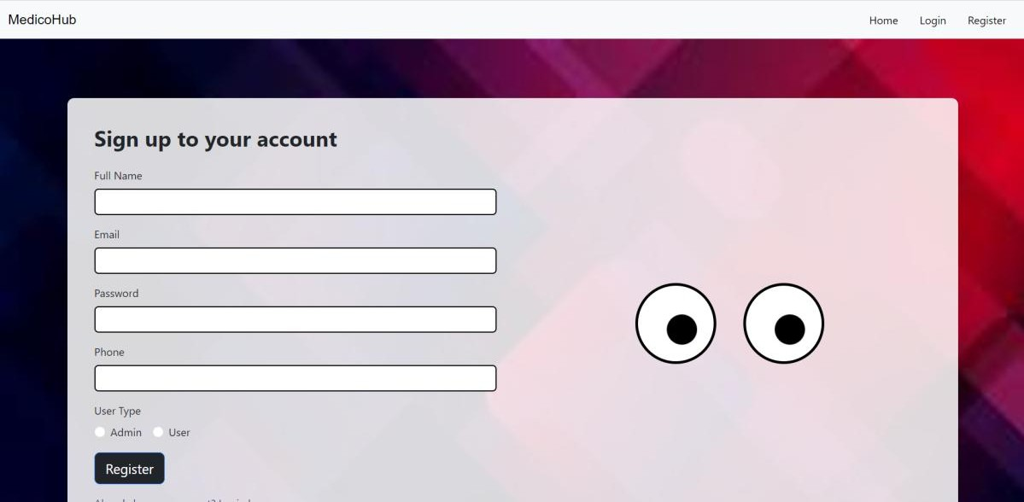
Testing:
  - Manual testing
  - JWT verification and API endpoint tests

Screenshots or Demo:
(Add demo/video links)

Known Issues:
  - Occasional delay in backend responses
  - Admin panel UI improvements needed

Future Enhancements:
  - Add payment integration
  - Add video consultation feature
  - Implement analytics dashboards

